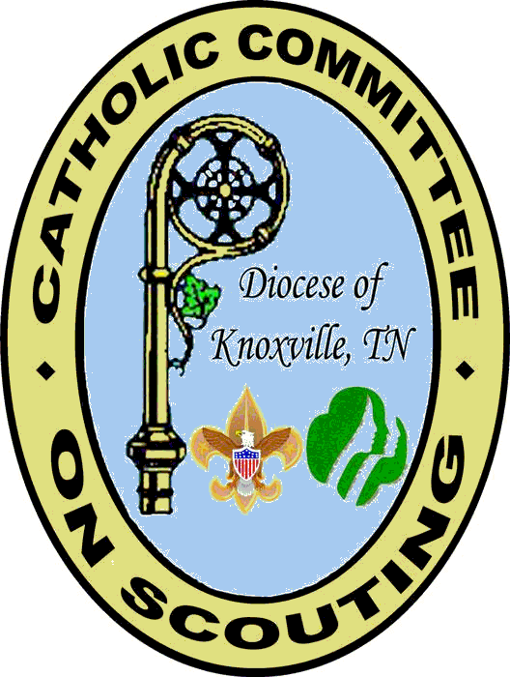

Catholic Committee on Scouting
Knoxville Tennessee
Diocesan Catholic Committee

Recommendation
For the

Bronze Pelican Emblem

Candidate

Name: ______________________________________________ Address: ________________________________

City: __________________________ State: __________ Zip: ________________ Phone: _______________

Parish: ______________________________________________ Address: ________________________________

Registered in Scouts as: ________________________________ Council: ________________________________

Recommendation By: __________________________________ Phone: H - _____________ W - ____________

Parish Approval

The above named candidate is hereby approved as worthy of receiving this emblem.

Pastor Signature: _______________________________________ Date: ___________________________

Diocesan Approval

The Bronze Pelican Selection Committee of the Diocese of Knoxville Tennessee certifies that the record of service of the above named candidate has been carefully reviewed and that this candidate meets the requirements for receiving this emblem as defined by this diocese and approved by the ordinary.

Signature: ____________________________________ Date: ________________________________
Chairperson Selection Committee

Signature: ____________________________________ Date: ________________________________
Diocesan Chaplain

Diocesan Record

Date Emblem Ordered: __________________________

Date Emblem Received: __________________________

Date Emblem Presented: _________________________ By: _________________________________

Emblem No. ________________ In the Diocese of Knoxville Tennessee.

Note’s

Instructions

The Bronze Pelican Emblem is a diocesan recognition awarded by the Diocesan Catholic Committee on Scouting with the approval of the Bishop. It may be presented to any adult working in the Scouting Program under Catholic auspices, to Catholics in Units not partnered by the Church, and to those who have made a significant contribution to Scouting in the field of Catholic relationships. It may be given to Catholic men and women, including priests and religious.

The purpose of this emblem is to recognize an outstanding contribution to the spiritual development of Catholic youth in the Scouting Program.

All recommendations shall be forwarded to the Selection Committee after parish approval is received. NOTE: Applications received without parish approval or not completely filled in will not be considered for the emblem. Please attach typed or computer generated document listing the criteria the eligible candidate has met. You must respond to 50% or more of the bullets under Guide for Selection.

Guide for Selection Committee

Following are some examples, a combination of which might make a leader an eligible candidate for this recognition. These suggestions are offered as a guide only; however, they are indicative of some of the things that the Selection Committee will be looking for. This list is not inclusive, as there are many other areas that could be considered.

- Promote the Religious Emblems Program for Catholic youth and serve as a counselor.
- Encourage non-Catholic youth to participate in the Religious Emblems Program of their Faith.
- Notable service in promoting Catholic activities and services projects for the church and willingness to serve on like committees.
- Active participation in the Scouter Development program, youth retreats or days of recollection—instrumental in having others participate.
- Outstanding service in promoting and participating in Scout Sunday observance.
- Notable Service in bringing Scouting to more youth under Catholic auspices.
- Assist parishes and Catholic organizations in recruiting Scoutmasters or other key leaders.
- One who is fully trained in the skills of Scouting and outstanding for his/her sense of responsibility, humility, and good example.
- Responsible for Catholic youth being transported to Mass at camporees and summer camps and providing for the spiritual needs of any non-Catholics within these groups.
- Encourage the true spirit of ecumenism as well as parochial responsibility and Catholic leadership within various Scout units under Catholic auspices.
- Instrumental in promoting the full Scout Programs in all parishes, including multiple units where needed.
- Making a significant contribution to Scouting or in the field of Catholic relationships.
- Through the Catholic press and other communication media, create a better understanding of the aims and ideals of Scouting by clergy and laity.

This form, together with a check for $27.00 (payable to KDCCS = Diocesan Catholic Committee on Scouting) to cover the following:

Bronze Pelican recognition packet
Bronze Pelican miniature emblem (for civilian wear) $27.00

Should be mailed to:

George C. LeCrone, Sr.
Chairman, Catholic Committee on Scouting
10700 Leeward Lane
Knoxville, Tn. 37934

Or

Rev. Mr. Otto Preske
Chaplain, Catholic Committee on Scouting
535 Buckhorn Road
Gatlinburg, TN 37738

